Assignment – 14

Entering, Deleting, and Changing Field Values

1. Write a command that puts the following values, in their given order, into the salespeople table: city – San Jose, name – Blanco, comm – NULL, cnum – 1100.

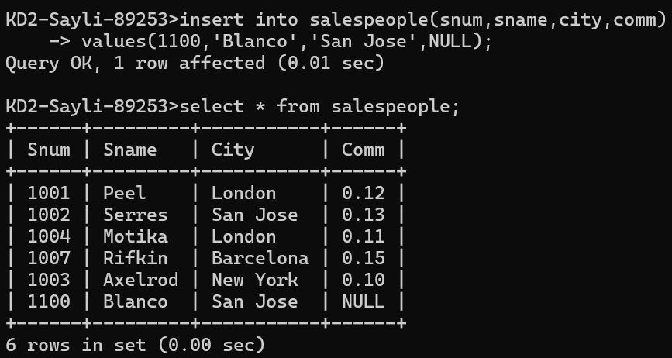

1. Write a command that removes all orders from customer Clemens from the Orders table.

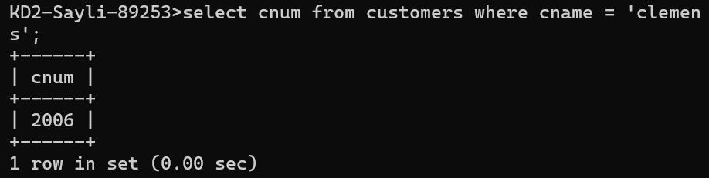

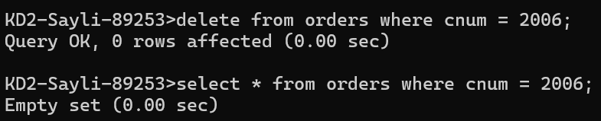

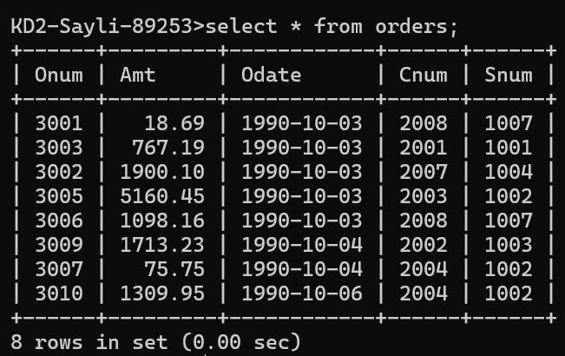

1. Write a command that increases the rating of all customers in Rome by 100.

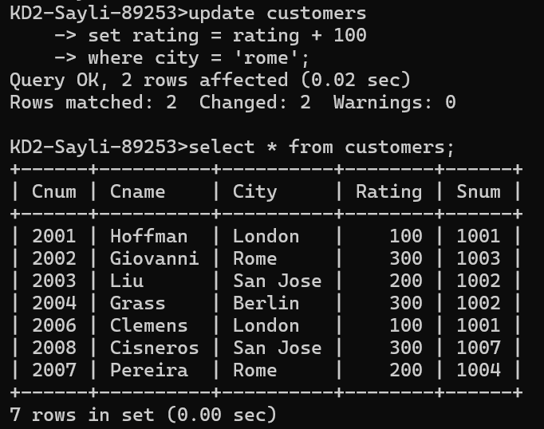

1. Salesperson Serres has left the company. Assign her customers to Motika.

